# Numbering Olympic athletes by medals earned with CTE

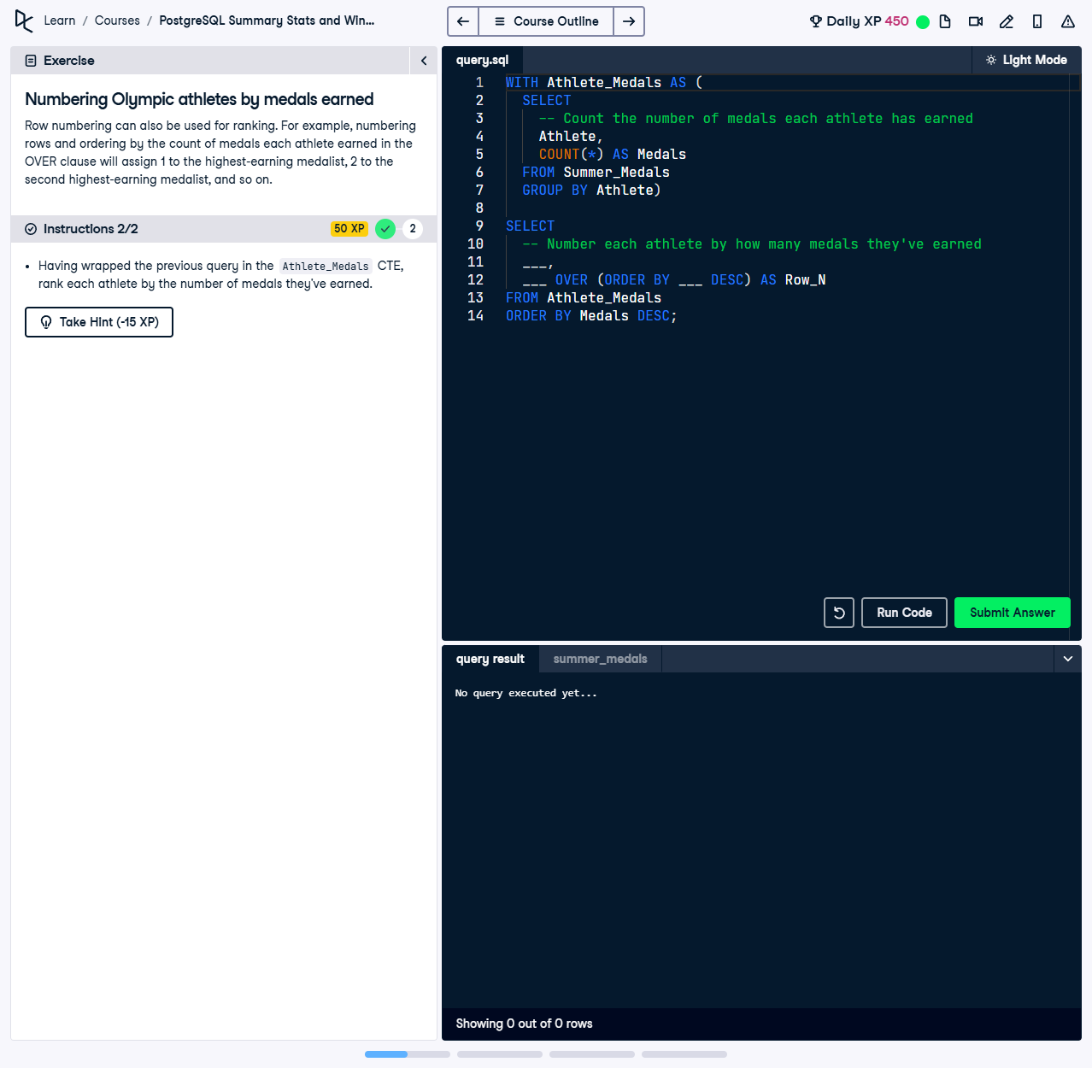

Row numbering can also be used for ranking. For example, numbering rows and ordering by the count of medals each athlete earned in the `OVER` clause will assign 1 to the highest-earning medalist, 2 to the second highest-earning medalist, and so on.

This exercise uses a Common Table Expression (CTE) to count the number of medals each athlete has earned, and then numbers each athlete based on the total medals in descending order.

## Correct Answer

WITH Athlete_Medals AS (  
 SELECT  
 Athlete,  
 COUNT(*) AS Medals  
 FROM Summer_Medals  
 GROUP BY Athlete  
)  
SELECT  
 Athlete,  
 Medals,  
 ROW_NUMBER() OVER (ORDER BY Medals DESC) AS Row_N  
FROM Athlete_Medals  
ORDER BY Medals DESC;

Explanation of the query:

1. `WITH Athlete_Medals AS (...)`: This CTE calculates the total number of medals earned by each athlete by counting the rows in the `Summer_Medals` dataset and grouping them by `Athlete`.

2. `ROW_NUMBER() OVER (ORDER BY Medals DESC) AS Row_N`: Assigns a unique rank to each athlete based on the total number of medals in descending order, starting with 1 for the top medalist.

3. `ORDER BY Medals DESC`: Ensures the final result is sorted by the total medals in descending order to align with the ranking.